What is a DataFrame?

A Pandas DataFrame is a 2 dimensional data structure, like a 2 dimensional array, or a table with rows and columns.

Example

Create a simple Pandas DataFrame:

import pandas as pd  
  
data = {  
  "calories": [420, 380, 390],  
  "duration": [50, 40, 45]  
}  
  
#load data into a DataFrame object:  
df = pd.DataFrame(data)  
  
print(df)

Result

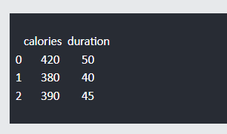

<https://www.w3schools.com/python/pandas/pandas_dataframes.asp>

<https://www.geeksforgeeks.org/python-pandas-dataframe/>